**Mr. Visca’s: Calculus (Chpt 4.5)**

**Chpt 4 – Day 10: Modeling and Optimization**

**4.5 Linearization and Differentials**

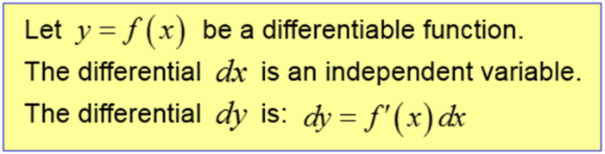

We are used to seeing this, given: y = f(x), then

DIFFERENTIALS:

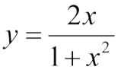Ex. For the given function, find dy, then evaluate dy for x = -2 and dx = 0.1

Estimating change with Differentials:

The function, f, changes value when x changes from a to a+dx. Find,

a) the true change ____________________________

b) estimated change ____________________________

c) approximation error ____________________________

f(x) = x2 + 2x, a = 0, dx = 0.1

Estimating change with Differentials:

The radius, r, of a circle increases from 10m to 10.1m. Use dA to estimate the increase in the circle's area. Then compare this estimate to the true change, find the approximation error. (Areas in terms of pi)

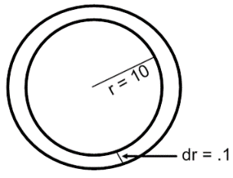

In the 1830s, French physiologist, Jean Poiseuille (pwa-ZOY) discovered the formula we use today to predict how much the radius of a partially clogged artery has to be expanded to restore normal flow. His formula, V = kr4, says that volume V of a fluid through a small pipe or tube in a unit of time at a fixed pressure is a constant times the fourth power of the tube's radius r. How will a 10% increase in r affect V?

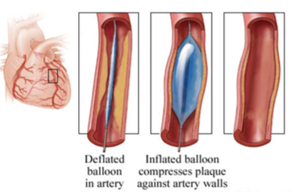

**HOMEWORK:**

Page 243 (20-34 evens (omit 30), 35-38 all)